Chelsea EDC Asks Community: “How Can We Make the Neighborhood Better?”
Public Meetings January 28th and February 10th

For Immediate Release Contact: Elizabeth Terenik, ETerenik@ACDEVCO.org, 609-425-9207

Community development corporations (CDC) throughout the State and country are having significant positive impacts in neighborhoods by bringing together businesses, residents and anchor institutions to identify goals and complete projects. As a non-profit, CDCs can apply for grants for improvements and programs that make residents lives better and grow the local economy.
On January 28th and February 10th, Atlantic City’s newest CDC, the Chelsea Economic Development Corporation, is seeking input from the Chelsea community to learn the neighborhood’s top priorities.

Tuesday, January 28th
5:00 PM Refreshments and Community Information
6:00 PM Presentation
7:00 PM Public Input
Chelsea Tower at the Tropicana
111 S. Chelsea Avenue
Free parking at 60 S. Montpelier (behind Walgreens)

Monday, February 10th
5:00 PM Refreshments and Community Information
6:00 PM Presentation
7:00 PM Public Input
Our Lady Star of the Sea Memorial Hall
Next to 15 N. California
Free parking on street and in church lots

Starting at 5:00 p.m., refreshments will be served and a dozen community organizations will be offering information, resources and grant information, including Atlantic City Police Department, South Jersey Gas Energy Assistance Team, First Time Homebuyer Incentives, Census 2020 job recruitment, AtlantiCare, Atlantic City Arts Foundation, NJ Economic Development Authority and others.
Starting at 6:00 p.m., a panel of top leadership from large neighborhood organizations such as Stockton, South Jersey Gas, ACPD, Tropicana, and DEVCO, will be speaking about their current contributions and future vision.
7:00 p.m. starts the public comment portion of the meeting. The opportunity for public comment will continue for several months as Chelsea EDC representatives can meet with individuals and groups. There will also be on-line and paper surveys available and information on www.Chelsea-EDC.org.
The Chelsea EDC’s board of directors represent a cross section of the neighborhood, including residents, small business owners, and representatives of large organizations and employers. They are committed to work with the community to identify common goals.
Dave Robbins, President of South Jersey Gas and Chelsea EDC Board Chairman will be speaking at the event. He stated “The Chelsea EDC is incredibly excited about hosting these community meetings. Our collective goal is to transform the Chelsea neighborhood as we know it today by stimulating economic development and improving the overall quality of life for residents and business owners alike.”
Once a CDC completes a neighborhood plan, they can apply for grant funding from several sources including up to $985,000 per year from the New Jersey Neighborhood Revitalization Tax Credit (NRTC) Program. Meaningful public input is evaluated with the grant applications, so community turn-out is critical to getting funding. ACDEVCO will serve as the partner non-profit for the application until the Chelsea EDC establishes a financial track record.
Some examples of projects that can be funded by the NRTC Program include:
- construction or rehabilitation of housing for residents
- home buyer education and incentive programs
- actions to increase business activity in the neighborhood including grants and loans to small businesses
- programs that increase job opportunities of neighborhood residents, including education, training, child care and transportation assistance;
- youth programs that provide recreation, job, career, or skills training

In addition, the NRTC program can fund infrastructure, beautification, public open space, community services, health care, crime prevention, recreation activities, community health services, and community outreach.
The Plan requires information on the neighborhood, such as population, number of businesses, and community buildings. Yet it’s the community-recommended projects that serve as the catalyst to attract grant funding. The proposed focus area, Texas Avenue to Annapolis Avenue, qualifies for the funding based on household income levels of the residents in those census tracts (3, 4, and 5).
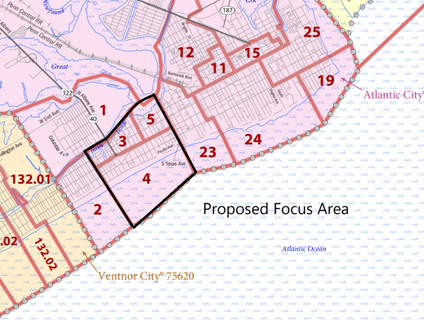
For more information, go to www.Chelsea-EDC.org.

